1. Write a c++ program to find size of int, float, double and char in your computer

Code:

#include <iostream>

using namespace std;

int main()

{

cout << "Size of char: " << sizeof(char) << " byte" << endl;

cout << "Size of int: " << sizeof(int) << " bytes" << endl;

cout << "Size of float: " << sizeof(float) << " bytes" << endl;

cout << "Size of double: " << sizeof(double) << " bytes" << endl;

return 0;

}

Output:

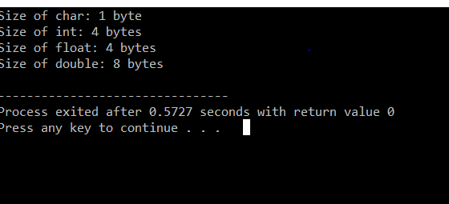

1. write a c++ program to find the product of two number entered by the user?

code

#include <iostream>

using namespace std;

int main()

{

float a,b,product;

cout<<"Enter two numbers:";

cin>>a>>b;

product=a\*b;

cout<<"Product= "<<product;

return 0;

}

Output:

